VoIP phone User Manual

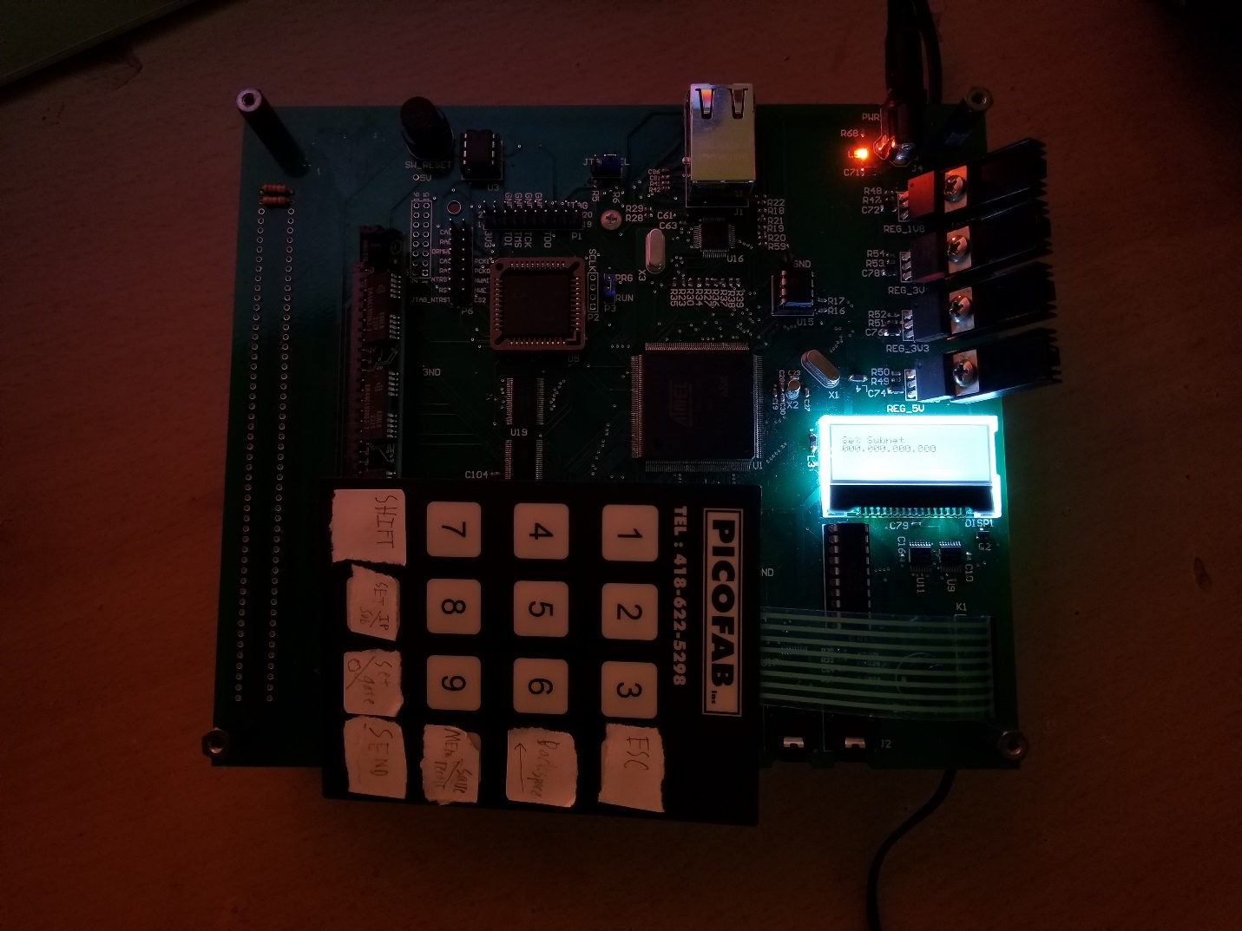

The EE52 VoIP phone is a phone that can communicate with other EE52 VoIP phones. The user controls the phone by using a 128x32 display and a 4x4 keypad. There is a headphone and microphone jack that a headset can be plugged into, and there is a button for putting the phone “on-the-hook” to hangup the call.

Contents

System Specifications 3

Startup 4

Interfacing with the phone 5

Keypad 5

Display 5

Headset 5

Ethernet 5

# System Specifications

|  |  |
| --- | --- |
| Processor | Atmel AT91RM9200 |
| Input power | 8V-12V DC 5.5mm barrel jack |
| Display | 128x32 |
| Headphone Jack | 3.5mm mono audio jack |
| Microphone Jack | 3.5mm |
| Keypad | 4x4 button keypad |

# Startup

Plug the system into the wall with the provided 12V DC wall power supply. The system will initialize and run a full diagnostic test on the onboard memory. After the SRAM and DRAM have been thoroughly tested for errors, the display backlight will blink and then the status “Idle” will appear on the screen. The phone is now fully booted. Proceed to the next section “Interfacing with the phone”

## Resetting the system

Should something go awry in the system, and a reset is needed, simply press the reset button located along the same side of the pcb as the ethernet jack. The system will reset, the display will blink once the memory check completes, and the system is then ready to go.

# Interfacing with the phone

## Keypad

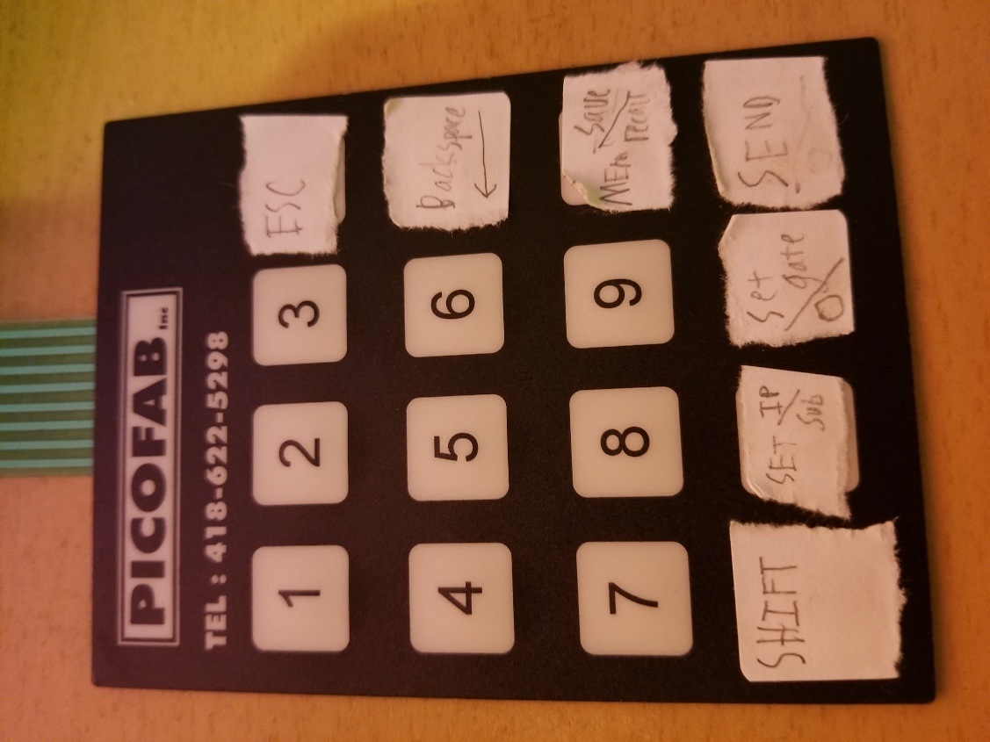

The keypad is a 4x4 keypad. Some keys are multiplexed using a shift key at the bottom left of the keyboard. The shift key toggles the keyboard between shift mode and normal mode. Note, this is different than the way most keyboards operate due to a limitation in the ability to detect multiple key presses.

Pressing Set IP/Sub allows the user to set the IP address and subnet mask using the numerical keys.

Pressing Set gate allows the user to set the gateway IP address.

Pressing Mem Save/Recall allows the user to save the current address configuration to an address location, or recall the IP settings from a memory location.

Pressing Send should initiate a call.

Note, due to a bug in the LWIP library, it is not possible to set more than 3 address settings, otherwise the system will crash.

## Display

The display is a 128x32 display, divided into 4 rows. Only the top two rows are used.

The top row displays the current menu the system is in, or the status of the system if a call is in progress.

|  |  |
| --- | --- |
| State | 1st Row message |
| Idle | Idle |
| Phone off hook | Off Hook |
| Ringing remote user | Ringing |
| Connecting to remote user | Connecting |
| Connected to remote user | Connected |
| Setting IP address | Set IP |
| Setting subnet mask | Set Subnet |
| Setting gateway IP address | Set Gateway |
| Saving settings to memory | Memory Save |
| Recalling settings from memory | Memory Recall |
| Settings recalled from memory | Recalled Message |
| Error occurred in software | Illegal Message |

The 2nd row displays auxiliary information for a menu, such as the IP address being set, the subnet mask, or the memory location for recall. The keyboard can be used to input data here, and save with the Send button.

## Headset

Two 3.5mm audio jacks are mounted next to the keyboard. J2 is the microphone, and J3 is the headset connection. The software has volume set capability, but the code must be recompiled to change it, so it is recommended the user use an adjustable volume headset.

## Ethernet

Ethernet is located on the same side of PCB as the power jack. The ethernet is designed to work in 10Mbps mode with RJ-45 connector-based cables. Currently, ethernet is not supported by this phone (what a great phone, I know).